Web Design

Test

Name: ____________________________

Date: _____________________________

This test paper will last for a duration of 2 hours (2:00 – 4:00). You are required to answer all the questions found in each task of this test paper

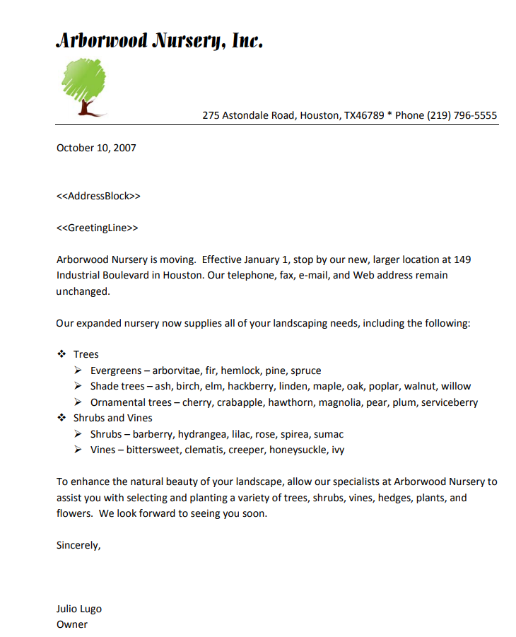

You are required to type the above file and execute the following:

1. Create a folder called my word testyour name on the desktop 1 Marks
2. Change the style of writing to Monotype corsiva 2 Marks
3. Change the size of writing to 12 pt. 2 Marks
4. Modify the font colour to pink or green 2 Marks
5. Display a water mark with your name on the document 5 Marks
6. Create a page border with lines around the entire document 2 Marks
7. Throughout the passage highlight the words trees, shrubs, vines, hedges, plants and flowers in the colour blue 3 Marks
8. You are required to send the above letter to the recipients found in the database below

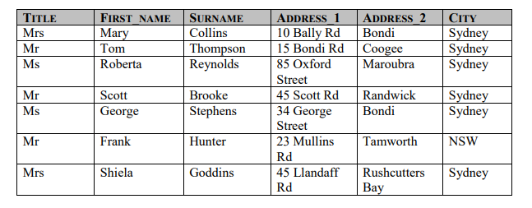

14 Marks

1. Save the document as mail merge activity and save it to your desktop folder 1 Mark
2. On a new word document create the following exactly as is and save it to the folder you created

6 Marks

1. save the files as word art document and save it to the folder you created on your desktop 2 Marks

Score

Total 40

TASK 2

Create the table as displayed below and complete the tasks which follows: 5 marks

|  |  |  |  |
| --- | --- | --- | --- |
| Name | Date | Package | Price |
| Paul Graham | 06/05/2016 | Ocean View | 20000 |
| Norman Roberts | 03/03/2016 | Mountain View | 35000 |
| John Lynch | 04/08/2007 | Ocean View | 25000 |
| Mary Green | 09/09/2016 | Mountain View | 35000 |
| Tyler White | 04/07/2018 | Mountain View | 20000 |

Tasks to complete

1. Remove the record of John Lynch 2 Marks
2. Insert the following record between John Lynch and Mary Green 4 Marks

|  |  |  |  |
| --- | --- | --- | --- |
| Peter Brown | 02/03/2018 | Ocean View | 30000 |
| Leona Lewis | 02/03/2018 | Ocean View | 35000 |

1. Change the style of writing for the document to Agency FB 2 Marks
2. Insert the Six Flags logo as a water mark for the document 4 Marks
3. Insert a header with your name on the document ensure it is centre aligned 3 Marks
4. Insert a footer on the document ensure it displays the page number of the document

3 Marks

1. Change the size of writing to 8 pt. 2 Marks
2. Save the file to the folder you created on the desktop as table exercise 2 Marks

**Score**

**Total /27**

**Compiled Score**

**Compiled Total 67**

**Compiled Percentage**